Marine Scotland Science

NOTICE TO MARINERS

Moray Firth Smolt Tracking Array

Issue date: Monday 19th August 2024

Marine Directorate (MD) intend to use an ROV to recover between 16 and 20 acoustic fish tracking moorings in the Moray Firth in the Beatrice and Moray East Offshore Wind farms (figure 1). The moorings hold research equipment that support hydrophone receivers. These receivers log the presence of fish, Cod, Haddock and Whiting tagged by the PrePARED team, which will be tagged with acoustic ID tags (they will also record other fish such as salmon and seatrout smolts (should they pass within range).

The proposed locations of the fish tracking moorings are shown (Figure 1); the positions of the moorings are given in WGS84 (Table 1). The moorings will be recovered from the 24th of August 2024 by a work catamaran under 25 metres in length (charter vessel to be confirmed, similar to one shown in Figure 5).

Acoustic fish tracking moorings are not surface marked as acoustic release systems have failed an ROV will be used from the boat to remove the mooring

**Contact details**

All enquiries should be made to the Marine Scotland acoustics mailbox [acoustics@scotland.gsi.gov.uk](mailto:acoustics@scotland.gsi.gov.uk)) marked for the attention of Robert Main. Switch Board Tel: 0131 244 2500

Figure 1: Moorings at BOWL and MEOW sites to be retrieved.

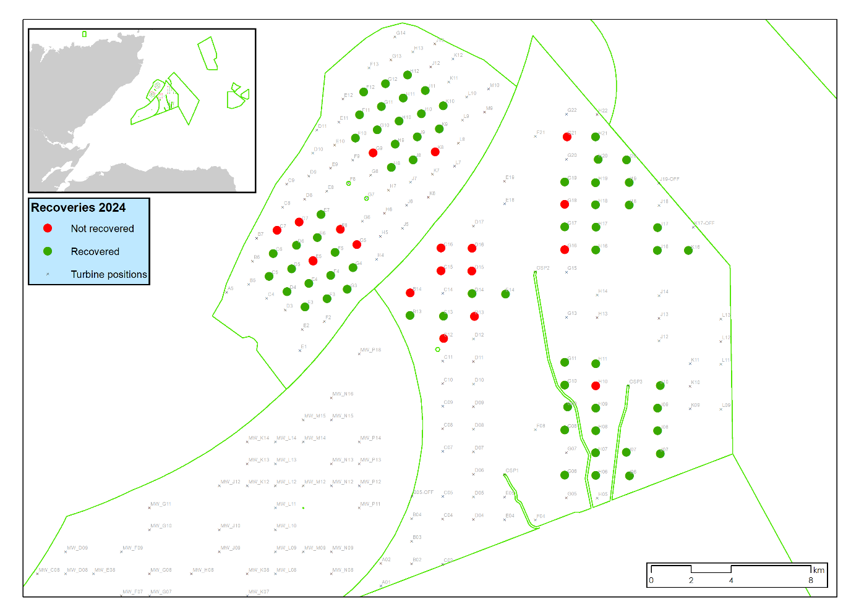

**Figure 2: Pop-Up array mooring design**

Acoustic receiver with rope canister and floatation. AR type mooring.

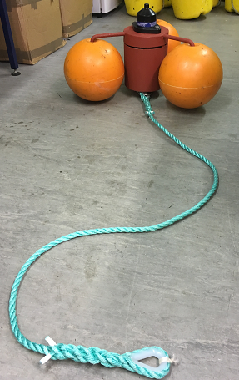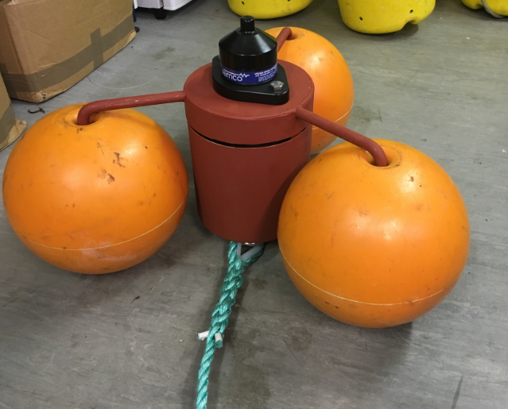

2 meters of Polysteel rope

70kg clump weight attached to bottom thimble

**Figure 5: Vessel type to be used**

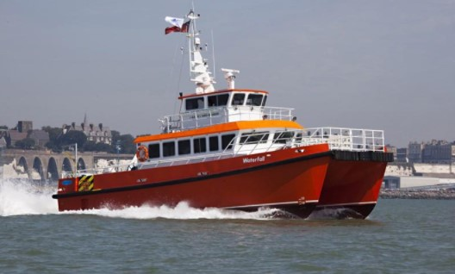

Table 1. Positions for the moorings to be recovered.

|  |  |  |  |  |  |
| --- | --- | --- | --- | --- | --- |
| **Station (turbine name)** | **AR-Number** | **Lat (Degrees decimal minutes)** | **Lon (Degrees decimal minutes)** | **Lat (Decimal degrees)** | **Lon (Decimal degrees)** |
| ME-H10 | 546202 | 58° 9.932' N | 2° 41.150' W | 58.165533 | -2.685833 |
| ME-G21 | 548879 | 58° 16.641' N | 2° 42.548' W | 58.27735 | -2.709133 |
| ME-G18 | 548288 | 58° 14.827' N | 2° 42.690' W | 58.247117 | -2.7115 |
| ME-G16 | 548287 | 58° 13.604' N | 2° 42.697' W | 58.226733 | -2.711617 |
| ME-D13 | 552438 | 58° 11.809' N | 2° 47.320' W | 58.196817 | -2.788667 |
| ME-D13 | 550104 | 58° 11.815' N | 2° 47.322' W | 58.196917 | -2.7887 |
| ME-D16 | 551852 | 58° 13.647' N | 2° 47.436' W | 58.22745 | -2.7906 |
| ME-D15 | 546209 | 58° 13.034' N | 2° 47.447' W | 58.217233 | -2.790783 |
| ME-C12 | 552527 | 58° 11.218' N | 2° 48.898' W | 58.186967 | -2.814967 |
| ME-C16 | 551899 | 58° 13.656' N | 2° 49.019' W | 58.2276 | -2.816983 |
| ME-C15 | 551897 | 58° 13.047' N | 2° 49.022' W | 58.21745 | -2.817033 |
| BE-K08 | 551863 | 58° 16.250' N | 2° 49.309' W | 58.270827 | -2.82182 |
| ME-B14 | 550097 | 58° 12.451' N | 2° 50.605' W | 58.207517 | -2.843417 |
| BE-G09 | 551871 | 58° 16.229' N | 2° 52.479' W | 58.270487 | -2.874645 |
| BE-G05 | 551851 | 58° 13.757' N | 2° 53.318' W | 58.229283 | -2.888633 |
| BE-F06 | - | 58° 14.168' N | 2° 54.169' W | 58.23614 | -2.902809 |
| BE-E05 | 552525 | 58° 13.314' N | 2° 55.561' W | 58.2219 | -2.926017 |
| BE-E05 | 546188 | 58° 13.324' N | 2° 55.565' W | 58.222067 | -2.926083 |
| BE-D07 | 546182 | 58° 14.365' N | 2° 56.277' W | 58.239417 | -2.93795 |
| BE-C07 | 551862 | 58° 14.141' N | 2° 57.399' W | 58.235683 | -2.95665 |