

## NOTICE TO MARINERS

Date of Issue: 2024.08.09

Our Ref: TT2413

Revision: 0

#### To: All Mariners & Navigational Authorities

MARINERS ARE ADVISED OF COASTAL MARINE SURVEY ACTIVITIES OFF WICK FROM 24th TO 29th August 2024

THE VESSEL SHALL BE RESTRICTED IN HER ABILITY TO MANOUVER, TETHERED ROV AND/OR OVER THE SIDE EQUIPMENT WILL BE IN USE

KEEP WELL CLEAR OF THE VESSEL WHILE UNDER SURVEY OPERATIONS

#### SUBJECT

* Caithness Moray HVDC link (Caithness/Wick landfall)

#### VESSEL

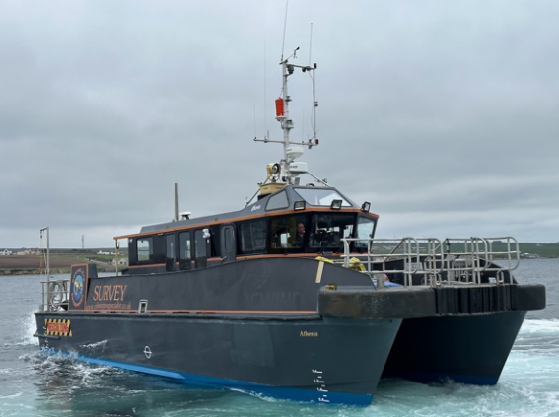

MPC Athenia – survey workboat (waterjet drive catamaran)

Please be aware that the vessel, Athenia, will be restricted in her ability to maneuver as defined under COLREGS (International

Regulations for Preventing Collisions at Sea 1972). Masters of vessel are therefore requested to maintain their vessels at a minimum

safe passing distance of 1000m.

* LOA: 18.5m
* BM: 6.1m
* GRT: 30.1T
* FLAG: UK
* MMSI: 235088194
* CALLSIGN: 2EUE2
* VESSEL PHONE: +447961597019

#### AREAS

3 x Survey area indicated in red in diagram below

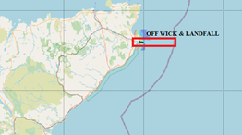

|  |  |  |  |
| --- | --- | --- | --- |
| AREA | BOUNDARY POINT ID | WGS84 | |
| Lat N | Lon W |
| Wick  Dogleg cable corridor | A | 58° 27.887’ | 003° 02.898’ |
| B | 58° 27.692’ | 002° 51.034’ |
| C | 58° 22.871’ | 002° 45.518’ |
| D | 58° 22.802’ | 002° 45.691’ |
| E | 58° 27.247’ | 002° 51.440’ |
| F | 58° 27.697’ | 003° 02.899’ |

#### DURATION

The vessel will be working through daylight hours only. The rough programme is:

|  |  |  |
| --- | --- | --- |
| Area | start | end |
| OFF WICK | 24 AUG | 29 AUG |

#### SSEN Transmission Fishing Liasson Officer Contact Information

* Company FLO (Blackhall and Powis):
* Tommy Finn Telephone Number: +44(0)7787503119 (NOTE THIS IS CORRECTED NR)

#### SSEN LEGAL DISCLAIMER

The Mariners are advised to exercise caution and follow any additional instructions provided. Please be advised that this Notice to Mariners should be treated as official notice of the nature, duration and location of the works which are scheduled to take place. During the period of this notice, failure to remove equipment or entry into the identified location in a manner that would constitute a hazard to the operations described may be considered a breach of the Convention on International Regulations for Preventing Collisions at Sea 1972 and/or the Merchant Shipping Act 1995 (a breach of which can carry criminal sanctions).